[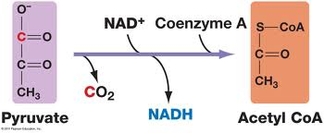](http://www.google.ca/url?sa=i&source=images&cd=&cad=rja&docid=CXxky1sEk7OkAM&tbnid=j0N1nx5JRb6gKM:&ved=0CAgQjRw&url=http://www.uic.edu/classes/bios/bios100/lectures/respiration.htm&ei=VEWiUuStLczXoASS7ICYBw&psig=AFQjCNE-PFEBe7nAgdsxO3-vE6p0sroLZg&ust=1386452692790504)