[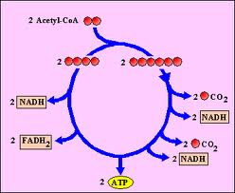](http://www.google.ca/url?sa=i&source=images&cd=&cad=rja&docid=VmpgpJoi6D1F0M&tbnid=LLNJ50p_F7U5nM:&ved=0CAgQjRw&url=http://www.uic.edu/classes/bios/bios100/lectf03am/lect11.htm&ei=3kWiUun7LsHUoAT02oHQCw&psig=AFQjCNFI9gfJyFnVC7L5RrOKukN0lc3qiQ&ust=1386452830822117)