Biology 20 Notes - Nutrients
- Vitamins and minerals Micronutrients

- Lipids (fats) Macronutrients

- Carbohydrates

- Proteins

- Nucleic Acids

Carbohydrates
- Provide fast source of energy and make up the largest components in most diets
Ex., potatoes, bread, corn, rice and fruit

- our body is unable to make them, we need to rely on plants

- They are macromolecules that always contain
carbon, hydrogen and oxygen; almost always in same
proportions: 2 atoms of hydrogen and 1 atom of oxygen
for every atom of carbon

- Carbohydrates are classified according to the number of sugar units they contain:

- _______________________ - single molecule of sugar
Ex.,

- _______________________ - 2 molecules of sugar

Ex., maltose = ______________ + _______________

Sucrose = ______________ + _______________

Lactose = ______________ + _______________

- ____________________ - 3 or more molecules of sugar

Ex., plants ->
Humans ->

Formation of Molecules
- All assembled in cells the same basic way

- ________________________________________
- To form a covalent bond between two subunit molecules, an –OH (hydroxyl) group is removed from one subunit and a hydrogen atom is removed from the other subunit
- Removing the –OH group and H atom during the synthesis of a new biological molecule essentially removes a molecule of water

- ________________________________________
- A molecule of water is added instead of removed
- A hydrogen atom from water is attached to one subunit and the hydroxyl group is bonded to another subunit effectively breaking a convalent bond in a macromolecule
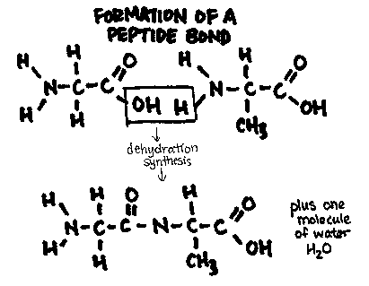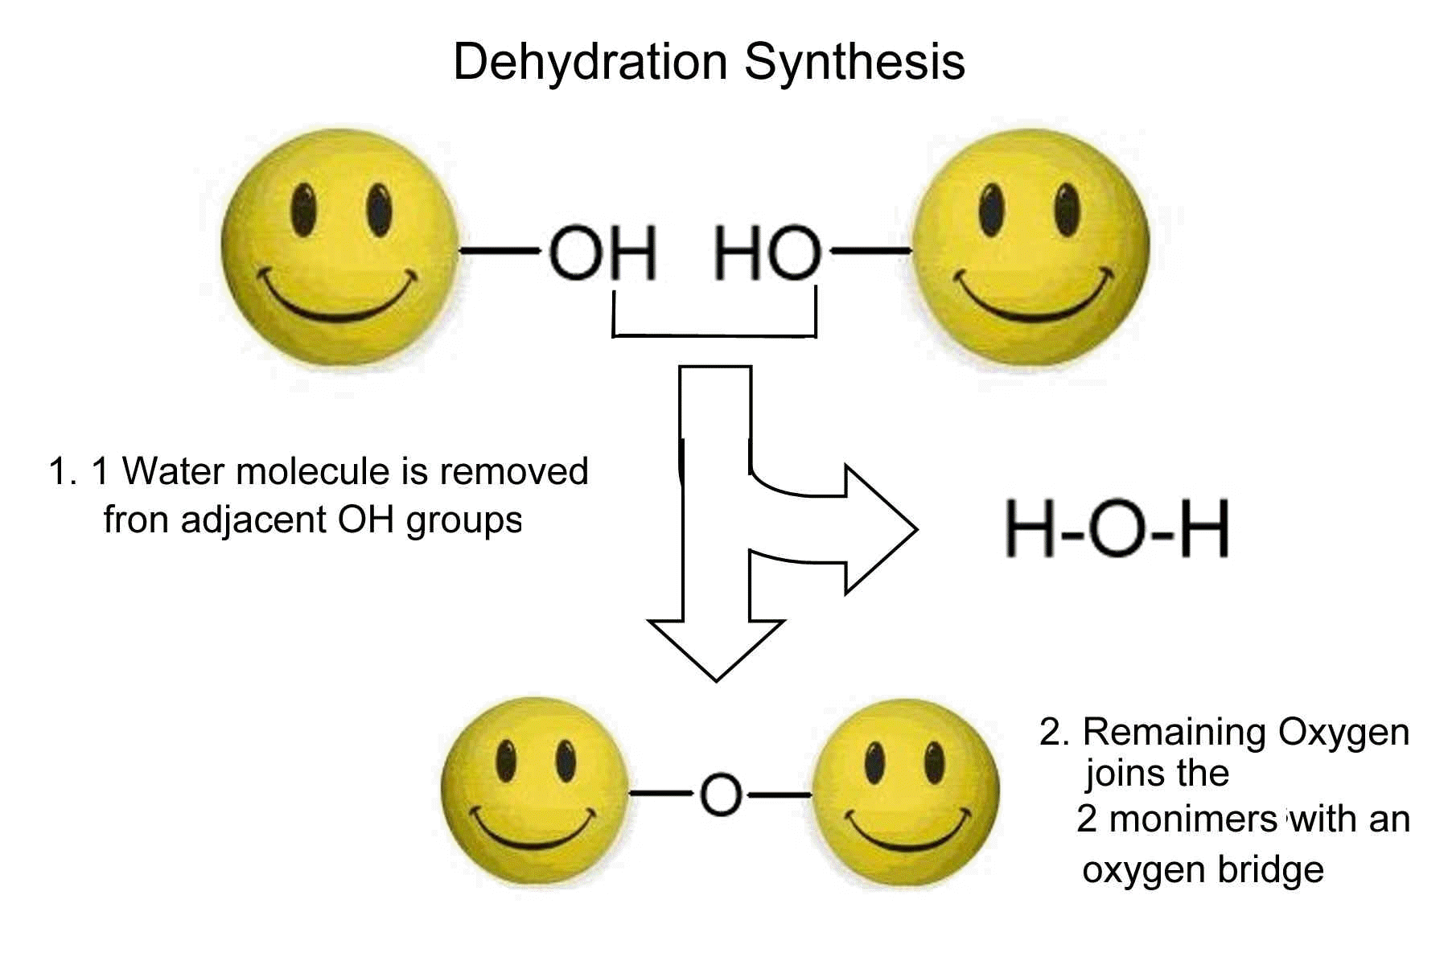
- Both processes are carried out in the cell and involve enzymes.

Lipids
- Diverse group of macromolecules – all are insoluble in water
- Store 2.25 times more energy per gram than other biological molecules
- Functions:

- _______________________
- Animal fats – ex., butter, lard
- Solid at room temperature
- Hard to break down
- Single bonds between carbons See figure 7 on p 246

- _______________________
- Liquid at room temperature – ex., vegetable oils
- Double bonds between carbons

- _______________________
- Waxy, fat like substance
- Found naturally in membranes
- Not all bad

Atherosclerosis –

Read the Case Study “Fats and Health” on p 248 and answer the questions that follow.

During the synthesis of a fat molecule, three fatty acid molecules bond with one glycerol molecule, and three water molecules are produced.

Proteins
- Structural component of cells
Ex., muscle, hair, nails, nerves, cell membrane
- Mitochondria and ribosomes are composed largely of proteins
- Antibodies are specialized proteins that help the body defend itself against disease
- Enzymes are proteins that speed up chemical reactions
- Contain carbon, hydrogen, oxygen, nitrogen, and often sulfur atoms]
- Can supply energy for tissues but not their main function
- Made up of 20 amino acids. 11 of which can be synthesized by the body and nine (essential amino acids) which must come from the diet.
- General structure of an amino acid:

- Order of amino acids determines the type of protein
- Polypeptides join amino acids together
- A chain of three or more amino acids is called a _____________________
- A proteins shape or structure determines its function

See fig. 13 on p251 for structure of protein.

Complete the following questions from your text.
P 245 #1-6
P 247 # 7-10
P 253 # 1 –3

Know TABLE 2 on p. 253

